Teaching Handout (SFIA)
Part 1 (Understanding SFIA)
SFIA stands for Skills Framework for the Information age. In its website SFIA is defined as ‘a model for describing and managing skills and competencies for professionals working in the Information and Communication Technology (ICT), software engineering and digital transformation.’
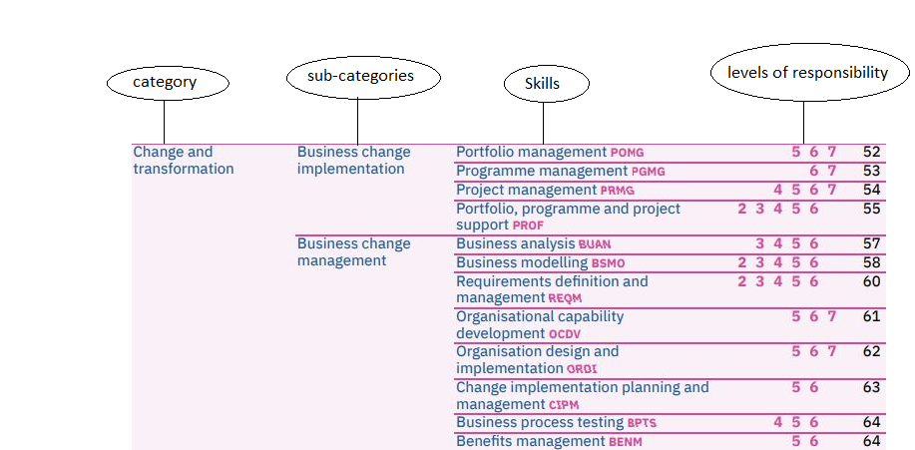
A picture showing the important parts of the document is attached below.

From the above picture, we can see that similar skills are categorized into a sub-category and these sub-categories are grouped to form a category. Such organization of skills make the document more systematic and helps us understand similarities and differences between skills.
Each skill is also attributed with different levels from 1 to 7. These are the levels of responsibility and explain each skill with respect to that level of responsibility. A skill may be attributed with any number of levels but must be attributed with at least one.
Part 2 (Current SFIA)
The way in which the SFIA is updated and kept relevant is through regular open consultation between the businesses within the industry that use the framework. This allows for the SFIA to provide a clear and consistent framework for which small and large organizations can share an approach, vocabulary and skill-based focus.
The SFIA consists of 102 professional skills, making it an incredibly in-depth framework describing skills that are required at specific levels of responsibility within the professional workspace.
Who is the SFIA designed for? The SFIA is designed for a wide range of working professionals from Line managers and human resource professionals to education providers as well as supply management and service providers.
The SFIA focus mainly on five areas of the IT industry, these areas are Software engineering, cyber security, digital transformation, big data and informatics and knowledge.
When the SFIA is discussed in regard to what updates should be made, it is always of the highest priority that the basic needs of the industry are met in such a way that one area is not overlooked in comparison to another.
Part 3 (Why use SFIA)
- Enable ICT and broader business to work towards similar goals.
- Can provide a clear understanding of standardized, leveled ICT skills across the organization.
- Enable targeted training to address specific skill gaps.
- To improve ICT recruitment.
- Assist with performance development of existing staff.

